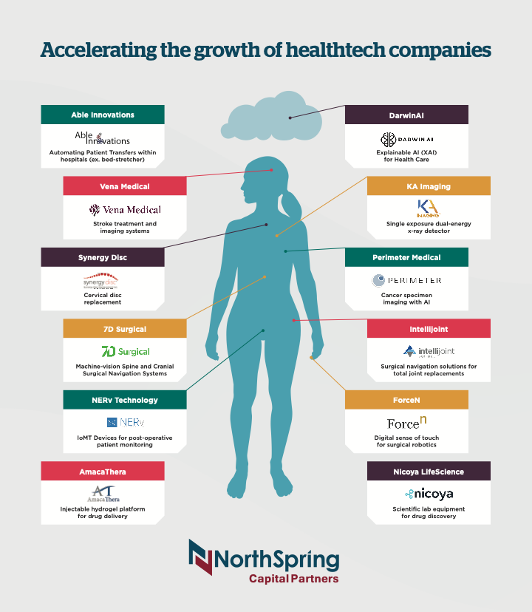

Meet Eve, named after our first fem-tech investment. She was built with Toronto-based Forcen’s Forcefilm on her hands and arms to give her a human sense of touch to safely handle the most delicate of objects. Poor Eve has had lots of health issues for an android.

Unfortunately, Eve has not been practicing social distancing. Examined with Waterloo-based KA Imaging’s Reveal dual-energy x-ray detector, she was diagnosed with Covid-19. Used with any standard x-ray machine, Reveal provides three views with only one exposure without motion artifacts (bone only, soft-tissue only and a combined view). This image was further analysed using Covid-Net, an open- source AI program developed by Waterloo-based Darwin AI to improve screening accuracy.

If only we had a rapid, low-cost diagnostic test for pandemic threats that could be self-administered without the need of a trained professional. Fortunately, help is on the way. Kitchener-based Nicoya Lifesciences has received funding to complete the development of their portable Covid-19 test which uses a simple saliva collection kit and smartphone app that will provide results in under 20 minutes.

Reveal also detected a lump on Eve’s breast. Surgeons successfully removed her tumour, which was intra-operatively analysed using Toronto and Dallas-based Perimeter Medical’s OTIS imaging system to ensure a positive margin of healthy tissue was excised. OTIS greatly reduces the risk of having to perform re-excision surgery after the pathology report is received, which happens in around 25% of cases. To improve accuracy and patient outcomes further, Perimeter raised funds from a successful public listing (TSX-V: PINK) to develop next-gen artificial intelligence and machine learning tools under its ATLAS AI project.

Eve was put together with some obsolete parts, which has led to severe back pain caused by degenerative disc disease. Fortunately, she was able to enrol in Synergy Disc Replacement’s current FDA trials. Synergy’s cervical discs correct motion, alignment and stability even in patients with spinal deformities. This surgery was successfully completed with the assistance of 7D Surgical’s spine and cranial machine-vision image guided navigation system. This system provides surgeons with real-time feedback without the need for CT images thereby eliminating intra-operative radiation to the patient and surgeon.

News of Eve’s successful spine operation reached Carlsbad, CA where SeaSpine (Nasdaq: SPNE) offered to buy 7D Surgical for $110 million.

During all of Eve’s surgeries she was injected with a novel pain therapy under development by Toronto-based AmacaThera. Their lead product, AMT-143, is a platform hydrogel technology being developed for the treatment of post-surgical pain with the goal of eliminating opioid use following surgery. It is administered as a single injection at the time of surgery.

After successfully recovering from the spinal surgery, Eve returned for hip surgery. Like most humans, she was concerned about the risks of dislocation and leg length discrepancies following the surgery. That’s why her surgeon chose Kitchener-based Intellijoint Surgical’s smart navigation system for joint replacement surgery to ensure accurate implant placement. This system has been used over 20,000 times for hips and is now available for knee replacements.

Eve was wheeled to and from the operating room and imaging suite on Toronto-based Able Innovation’s DELTA platform. A single operator was able to execute multiple lateral transfers from bed to table without the need of any physical exertion thereby providing a dignified experience for the patient and a reduced injury risk for the caregiver.

Eve does feel fortunate that she’s never had any heart or stroke issues. She’s pleased to know that Kitchener-based Vena Medical is developing the world’s smallest camera capable of going via catheter inside veins and arteries to help physicians identify and differentiate clots and treat stroke. For you technical readers, that a novel microangioscope for neuroendovascular intervention.

Speaking of catheters, Kitchener’s NERv Technology is developing a smart catheter system using miniaturized proprietary sensing technology. Leaks, bleeding and infection sometimes takes up to 2-3 days to detect. Using NERv’s system, detection time for general surgeries can be reduced to a matter of minutes and leakage-related surgical complications can be properly treated before they put patient’s lives in jeopardy.

About NorthSpring Capital Partners:

Established in 2009, NorthSpring Capital Partners is a private equity firm based in Cambridge, Ontario. We invest in passionate entrepreneurs and companies developing unique intellectual property, products and services targeting large addressable markets. Our financial resources and expertise accelerate the growth of innovative companies located in the Toronto to Waterloo technology corridor. Our affiliate, NorthBridge Consulting Services, assists clients with access to a variety of government funding programs including SR&ED.

For further information, please visit: www.northspringcapitalpartners.com or contact Brian Hunter, President at brian@northspringcapitalpartners.com or 519-721-7144.

